DICOM Convert Server

User Manual

Version 2.2
December - 2017

Ran Klein
+1 (613)-761-4072
www.ranklein.ca
rklein@toh.ca

University of Ottawa Heart Institute  Cardiac PET Unit  40 Ruskin St.  Ottawa, Ontario  K1Y 4W7  Canada   | The Ottawa Hospital  Department of Nuclear Medicine  1053 Carling Ave  Ottawa, Ontario  K1Y 4E9  Canada  

Disclaimer

The DICOM Convert Server is a tool included in the FlowQuant© package is protected under international copyright law. Use of this software without the sole permission of the University of Ottawa Heart Institute, Cardiac PET Centre is illegal.

FlowQuant© and the DICOM Convert Server is a research tool that is still in the development phase and is not approved for clinical use. Any use of FlowQuant is under the responsibility of the user and the results are not guaranteed by the developer.

Table of Contents
Disclaimer 2
Table of Contents 3
Introduction 4
Configuring the DICOM Convert Server 5
Configuration file (DICOMServer.dat) 5
Graphical User Interface - GUI 5
Running the DICOM Convert Server on Start-up 6
Sorting the converted files 6

Introduction

The DICOM Convert Server (DCS) is a Matlab tool that can be used to convert DICOM files to .mat format for faster and easier file access than multi-file DICOM series. The converted file format is advantageous as it loads faster and more easily into Matlab and requires less storage space and can be managed and distributed as a single file.

DCS is intended to run as an automated service on a host computer, typically on a network. DCS has been designed to work with various types of nuclear medicine modalities and vendors, specifically 3D and 4D (e.g. gated and dynamic) tomographs. However, due to the flexible nature of the DICOM image standard, there is no guaranty that DCS will work with all images. Thus, is was designed to be easily modifiable to accommodate unforeseen DICOM image series formats.

DCS can be compiled as a standalone executable which can then run as a background service. It is especially useful when paired with DICOM receiver node to automatically convert data as it is sent to the computer.

DCS monitors an incoming directory for new files and automatically converts them to .mat files that are saved to an outgoing directory. A temporary intermediate directory is used as part of the conversion process. These directories, along with other settings, are specified in a DICOMServer.dat file that in ASCII text format.

Incoming Directory
Temporary Directory
Outgoing Directory
DCS Log Screen
DICOM Convert Server Process
(Configure by DICOMServer.dat)
DCS Log File

Configuring the DICOM Convert Server
All configurations of the DICOM Convert Server are through the configuration file (DICOMServer.dat) which is stored in the same directory as the server executable (DICOMConvertServer.exe). If no configuration file exists the following default values will be used:

Default Configuration Settings
Entry name | Meaning | Entry value
indir | Directory in which DICOM files to convert may be found. | C:\DICOMImpot
outdir | Directory in which to store the converted files. | C:\DataStash
logdir | Directory in which to store log files of the conversion process. | C:\DataStash\Log
tempdir | Directory in which temporary intermediate files are stored. | C:\DataStash\temp
cleanup | Option for cleaning up the input directory as part of conversion. 1-enable, 0-disable. It is strongly recommended that this field be left as 1. | 1
overwrite | Option to overwrite output files with the same name (1), or give conflicting file names sequential numbers (0). | 0

Configuration file (DICOMServer.dat)
An example configuration file is shown below. Entries follow the format of entryName = entryValue. Unknown entry names are ignored and default values (see table above) will be used. All entry names are lower case and case sensitive.

Example Configuration File Content
% Written by setDICOMServerGUI
% Date: 06-Jun-2008 13:53:46
indir = C:\dicomReceiverRepository
outdir = c:\DataStash
tempdir = c:\DataStash\temp
logdir = c:\DataStash\Log
cleanup = 1
overwrite = 0

Graphical User Interface - GUI
DCS also include a graphical user interface (GUI) that can be used to configure and launch DCS. The GUI contains the same fields as mentioned above and stores the entered values in the configuration file. The Browse buttons may be used to select a directory using a browser interface. The Start Server button may be used to start the DCS with the current GUI settings GUI (the configuration files is updated as part of this operation).
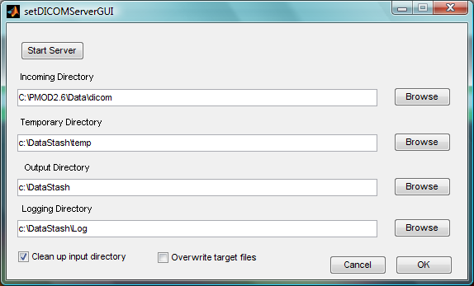

Running the DICOM Convert Server on Start-up
If you’d like the DCS to start automatically when the computer is started compile DCS as a standalone executable (.prj file included), add a shortcut to the Windows™ start menu, startup directory. This can be done by dragging the DICOMConvertServer.exe file into the menu. A shortcut will be created automatically by windows. Refer the Windows documentation for more information on creating shortcuts in the startup directory.

Sorting the converted files
The DCS dumps all converted files into the outgoing directory with descriptive file names, based on the description information in the file (patient name, study type, radio-pharmaceutical, etc). In order to avoid a large accumulation of files in this directory, it is recommended that the files then be transferred to a database or organized directory structure.

